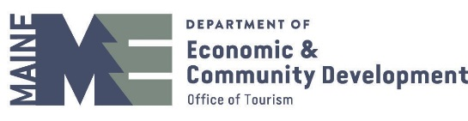
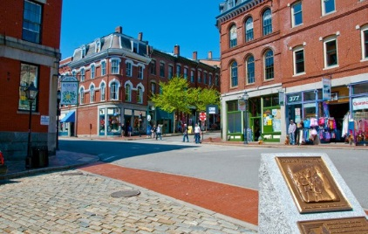
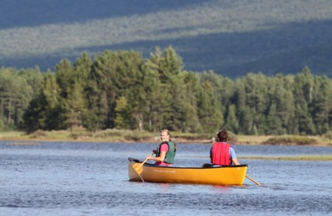
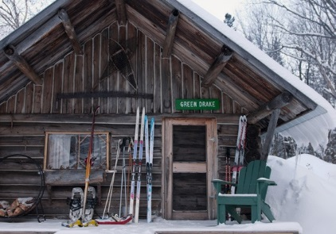
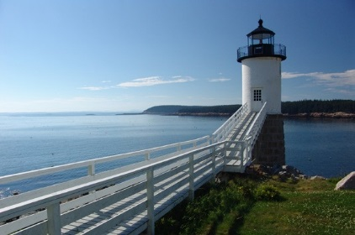
STAFF

Steve Lyons – Director

Phone: 207-624-7483; Email: steve.lyons@maine.gov
Contact Steve for questions regarding overall strategy and administration of the Office of Tourism’s tourism marketing program, and presentations at conferences and other tourism-related special events

Christine Bratcher – Development Project Officer

Phone: 207-592-6251; Email: christine.bratcher@maine.gov
Contact Christine for questions regarding the Maine tourism assets inventory project.

Karen Carberry Warhola – Director, Maine Film Office

Phone: 207-624-9828; Email: karen.carberrywarhola@maine.gov
Contact Karen for questions regarding film and television production in Maine.

Hannah Collins – Deputy Director
Phone: 207 – 624 -7456; Email: hannah.collins@maine.gov
Contact Hannah for questions regarding Maine’s Destination Management Plan, Cruise Maine, and regional destination marketing.

Jennifer Geiger – Communications Manager

Phone: 207-624-7454; Email: jennifer.geiger@maine.gov
Contact Jennifer for questions regarding PR, state media and industry communications, consumer travel shows, international marketing, and the Governor’s Conference on Tourism.

Donna Moreland – Destination Development Specialist

Phone: 207-624-9808; Email: donna.moreland@maine.gov
Contact Donna for questions regarding rural destination development and fostering rural tourism business development.

Chiara Moriconi – Senior Tourism Officer
Phone: 207 – 624 -9809; Email: chiara.moriconi@maine.gov
Contact Chiara for questions regarding group tour, domestic and international itineraries, meetings development, and Maine Tourism Enterprise and Event grants.

Micki Mullen – Marketing Manager

Phone: 207-624-7495; Email: micki.mullen@maine.gov
Contact Micki for questions regarding MOT’s advertising program, research, and fulfillment.

Abbe Levin – Cultural Tourism Consultant

Phone: 207-633-6141; Email: alevin@gwi.net
Contact Abbe for questions regarding arts, cultural and heritage tourism in Maine.

Lisa Poulin – Secretary Associate

Phone: 207-624-7483; Email: lisa.poulin@maine.gov
Contact Lisa for general inquiries and fulfillment requests.

The Office of Tourism offers a variety of marketing tools and programs designed to support and expand Maine’s tourism industry. Read through the list of resources below and make sure you are benefiting from all the available tools and information that can help advance the success of your business or organization.
INDUSTRY RESOURCES CHECKLIST
- MOTPartners.com
Stay updated on the Maine Office of Tourism’s annual Marketing Plan, 5-Year Strategic Plan, Advertising Program, Destination Development and Creative Materials, plus Visitation Fact Sheet and industry-related Research, with useful information on Maine visitor spending, demographics and interests, to help you understand your audience; all this and more at MOTPartners.com.

VisitMaine.com
Add your FREE tourism Business & Event Listings to VisitMaine.com, the state’s primary online resource for tourism.
Connect through the PARTNER LOGIN tab at MOTPartners.com.

Maine Tourism Marketing Partnership Program
The MOT grant programs provide funding for targeted tourism marketing efforts within the state of Maine.
Special Event and Tourism Enterprise Marketing Grants make it possible for smaller organizations to partner with the MOT to move projects to the next level. Learn more at PROGRAMS & SERVICES on MOTPartners.com

PR Partners Program
Our PR Partners program helps bring print and broadcast travel and lifestyle journalists, photographers, bloggers and
international tour operators to Maine to connect with our state’s hospitality industry and Maine travel experiences. Download the online application under PROGRAMS & SERVICES/PR at MOTPartners.com.

“Look Out For ME” Digital Toolkit
Our goal is to ensure that visitors and residents alike venture out safely and responsibly, with a great respect for the land we all love and cherish. Check out the digital tool kit here: motpartners.com/look-out-for-me-toolkit/

Social Media
Connect and engage with the Maine Office of Tourism through Facebook, Instagram, Twitter , Pinterest, and YouTube.
Follow/Like/Engage with us: @VisitMaine #mainething.

Maine Tourism Partner News
Our monthly industry newsletter will keep you up to date on tourism industry research, MOT activities, and collaborative
marketing opportunities. Email Jennifer.Geiger@maine.gov to receive the monthly email in your own inbox.

Governor’s Conference on Tourism
Attend the annual conference for professional development, training & networking opportunities tailored to your needs. Stay up to date with trends in tourism, and align with the MOT marketing plan to enhance your own outreach efforts. Details at mainetourismconference.com.

Maine Film Office Website
Create free listings for your business or property on FilmInMaine.com. You can list your business in the Production Guide, or property in the Locations Library, so productions scouting Maine can find you.

WelcomeME and R-Way Workforce Training
Management and staff alike benefit from these Online Customer Service Training Tools, available under ADDITIONAL RESOURCES/EDUCATION AND TRAINING at MOTPartners.com.

